NAME: Dave Nearing CS466-001
CHAPTER: 3
LAB: 3

For each chapter, you will complete a set of Animated Flashcards, Book exercises, and Lab exercises. Although you will have three different activities, you will submit them in one document. Use this document to record your answers for submission.

ANIMATED FLASHCARDS

In order to receive any point value for the Book and Lab exercises, you must submit your answers to the chapters corresponding eLearning module or the course schedule for the assigned chapter exercises. Identify your responses to the exercises by including their numbers as they appear in the chapter in this section.

1. Run length encoding
2. Data compression
3. Keyword encoding
4. Resolution
5. Overflow
6. Radix point
7. Multimedia
8. Pixels
9. Analog data
10. Video codec
11. Ten's complement
12. Temporal compression
13. Pulse-code modulation
14. Vector graphics
15. Reclock
16. Scientific notation
17. Information
18. Character set
19. Compression ratio
20. Digitize
21. Spatial compression
22. Floating point
23. Bandwidth
24. Data
25. Signed-magnitude representation
26. Lossy compression
27. Raster-graphics format
28. Huffman encoding
29. Digital data
30. Lossless compression

1. A
2. B
3. B
4. A
5. B
6. A
7. A
8. B
9. A
10. A
11. B
12. A
13. A
14. A
15. A
16. A
17. B
18. A
19. A
20. B
21. E
22. A
23. B
24. F
25. C
26. D
27. Because bandwidth is limited and the more you can compress data, the more data you can transmit over a connection.
28. Lossless-no information lost
Lossy-some information may be lost
29. Because analog information is continuous and infinite. Since computers are number-based machines, you have to convert analog data into digital data for the computer to be able to use it.
30. An analog device, because the hand is always moving, which is an example of continuous data.
31. Taking data and turning it into pieces that can be analyzed separately by a computer.
32. PCM describes the motion of a signal bouncing rapidly between highs and lows.
33. a. 16
b. 32
c. 64
d.128
34. a. -1
b. 45
c. 4
d. -42
e. 30
f. 11
g. -46
h. 16
35.
36.
37.
38.
48.
49. ASCII has 8-bit characters, Unicode has 16-bit characters.
50. Keyword table-
And = a
Or = o
Not = n
If = i
Dog = d
Cat = c
The = t
Went = w
Store = s
by = b
then = h
is = z
true = u

Paragraph-If the dog or the cat went by the store, then 'the dog and the cat went by the store' is true. The dog and the cat went by the store. The and is true. If the dog and not the cat went by the store, then the and is not true.
Compression- itdatcwbts,h'tdatcwbts'zu.tdatcwbts.tazu.itdantcbtshtaznu.
Ratio- 100-(58/229)=~74.7%

51. *A4BBB*C8*D4 hi there *E9FF
~.66
52. XXXXXAAAAAAAAA
53. a. ELATE
b. CHORES
c. FANTASTIC
d. NONSENSE

LAB EXERCISES

The Lab Exercises are found on the textbook companion web site by clicking Explorations in Computer Science link, located in the left-side panel. Refer to the chapters number as you record your responses in this section.

Ex1.
1.
2. 1
3. one is 32 bits long, the other is 8 bits long.
4/5. 4
00000100
000000000100
0000000000000100
00000000000000000000000000000100

-4
11111100
111111111100
1111111111111100
11111111111111111111111111111100

6. -1
1111111111111111111111111111111111111111111111111111111111111111

-4
1111111111111111111111111111111111111111111111111111111111111100

7. 01111111111111111

8. 1000000000000001

01111111111111111
1000000000000001

-32767 is the inverted form of 32767 with a 1 on the front.

9. Error- this number can't fit in bits. No. each bit can store 2, 8/4 is 2. Should be enough bits.

Ex2.
2.
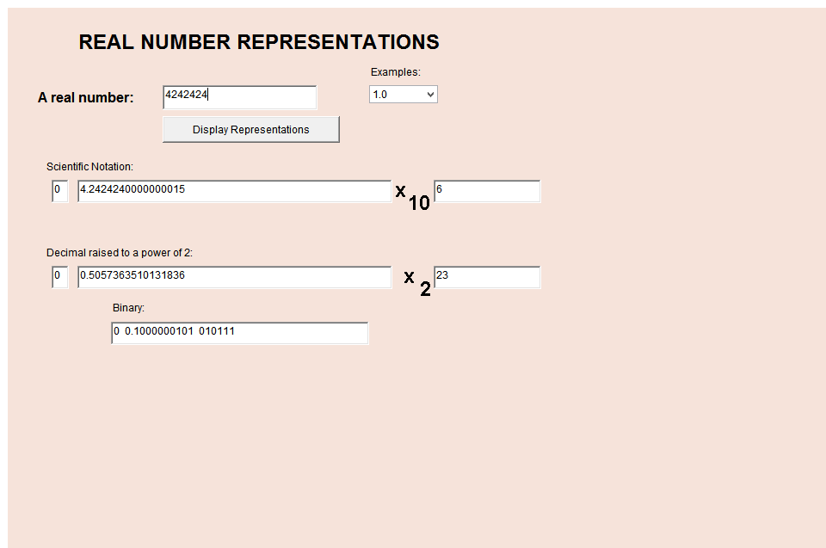

3. Seems that powers of 2 are around 4x the powers of 10.

4. 12
100000000000

5. -

6. It's always 1

7. 5.0x10^-1
2.5x10^-1
1.25x10^-1

it changes sign with the power
it changes sign
.0625

3C Ex1.
2.
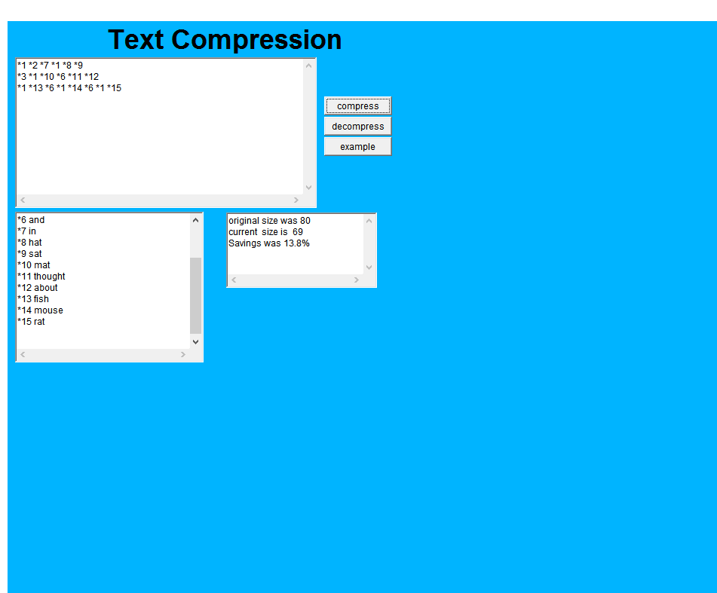

3. yes, if you preshared the compression key, then it would require the key to decompress it.
4. it ignores it.
Yes, it decompresses it as “*<STRING>”

5. you could use an escape character. The applet lets you define keywords/numbers like *n*p though, which works just fine.

